-

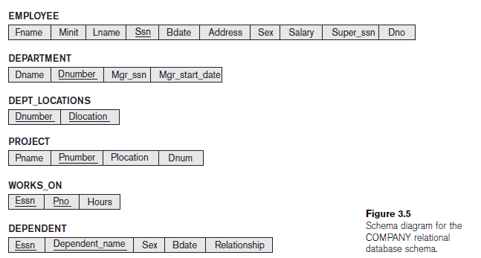

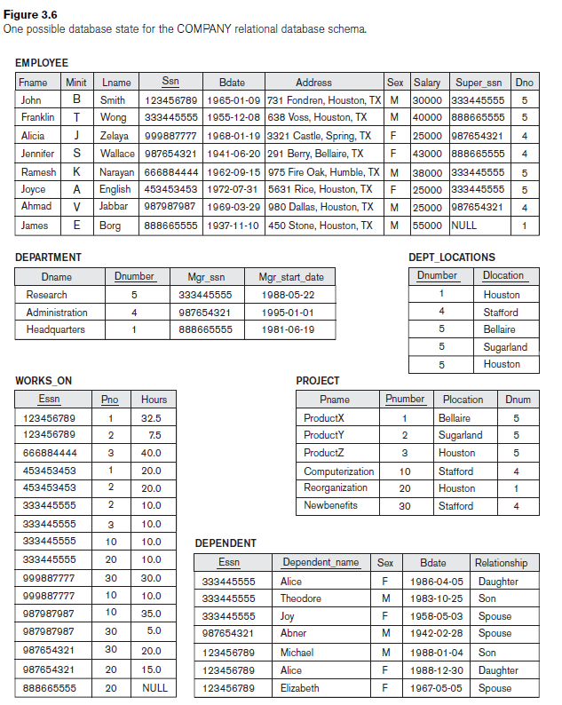

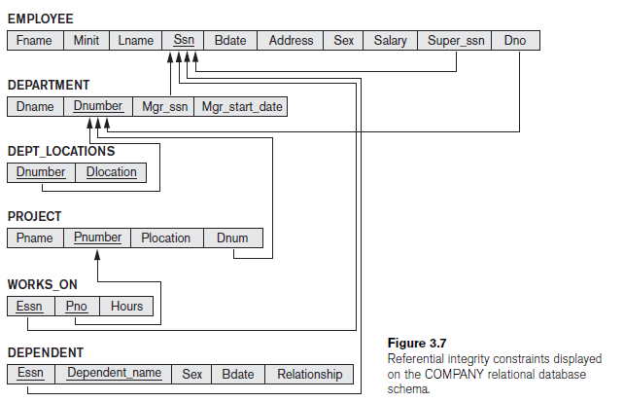

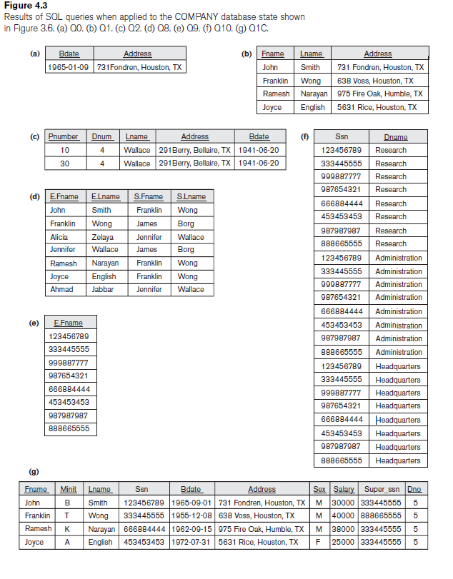

1. **Query .** Retrieve the birth date and address of the employee(s) whose name is ‘John B. Smith’.
2. **Query .** Retrieve the name and address of all employees who work for the

‘Research’ department.

1. **Query:** For every project located in ‘Stafford’, list the project number, the controlling department number, and the department manager’s last name, address, and birth date.
2. **Query:** For each employee, retrieve the employee’s first and last name and the first and last name of his or her immediate supervisor.
3. **Query:** Write a query which is retrieves all the attribute values of any EMPLOYE who works in DEPARTMENT number 5
4. **Query:** write a query which is retrieves all the attributes of an EMPLOYEE and attributes of the DEPARTMENT in which he or she works for research department (every employee )of the ‘Research’ department,
5. **Query:** write a query which is specifies the CROSS PRODUCT of the EMPLOYEE and DEPARTMENT relations.
6. **Query:** Select all EMPLOYEE Ssns in the database.
7. **Query**: Select all EMPLOYEE Ssns

1. **Query:** Retrieve the salary of every employee .
2. **Query:** Retrieve the all distinct salary value.
3. **Query:** Make a list of all project numbers for projects that involve an employee whose last name is ‘Smith’, either as a worker or as a manager of the department that controls the project.
4. **Query:** Retrieve all employees whose address is in Houston, Texas(TX).
5. **Query:** Find allemployees who were born during the 1950s.
6. **Query:** Show the resulting salaries if every employee working on the ‘ProductX’ project is given a 10 percent raise.
7. **Query:** Retrieve all employees in department 5 whose salary is between $30,000 and $40,000.
8. **Query:** Retrieve a list of employees and the projects they are working on, ordered by department and within each department, ordered alphabetically by last name, then first name.
9. **Query:** Retrieve the name of all employees who do not have supervisors.
10. **Query:** Retrieve the name of each employee who has a dependent with the same first name and is the same sex as the employee.
11. **Query:** write a query which is retrieve In general, a query written with nested select-from-where blocks and using the = or IN comparison operators can always be expressed as a single block query.
12. **Query:** Retrieve the names of employee who have no dependents.
13. **Query:** List the name of managers who have at least one dependent.

1. **Query:** Retrieve the Social Security numbers of all employee who work on project numbers 1, 2, or 3.
2. **Query:** Find the sum of the salaries of all employees, the maximum salary, the minimum salary, and the average salary.
3. **Query:** Find the sum of the salaries of all employees of the ‘Research’ department, as well as the maximum salary, the minimum salary, and the average salary in this department.
4. **Query:** Retrieve the total number of employees in the company.
5. **Query:** Retrieve the total number of employees in the company and the number of employees in the ‘Research’ department.
6. **Query:** Count the number of distinct salary value in the database.
7. **Query:** For each department, retrieve the department number, the number of employees in the department, and their average salary.
8. **Query:** For each project, retrieve the project number, the project name, and

the number of employees who work on that project.

1. **Query:** For each project *on which more than two employees work,* retrieve the project number, the project name, and the number of employees who work on the project.
2. **Query:** For each project, retrieve the project number, the project name, and

the number of employees from department 5 who work on the project.

1. **Query:** For each department that has more than five employees, retrieve the department number and the number of its employees who are making more than $40,000.